To plot Continuous and Discrete time signals

1. Plotting Continuous-Time Signals

For the following: Run the following three lines and explain why the plots are different.

t = 0:2\*pi; plot(t,sin(t))

t = 0:0.2:2\*pi; plot(t,sin(t))

t = 0:0.02:2\*pi; plot(t,sin(t))

For the last graph, add a title and axis labels with:

title('My Favorite Function')

xlabel('t (Seconds)')

ylabel('y(t)')

Change the axis with:

axis([0 2\*pi -1.2 1.2])

Put two plots on the same axis:

t = 0:0.2:2\*pi; plot(t,sin(t),t,sin(2\*t))

Produce a plot without connecting the points:

t = 0:0.2:2\*pi; plot(t,sin(t),'.')

Try the following command:

t = 0:0.2:2\*pi; plot(t,sin(t),t,sin(t),'r.')

What does the r do?

2. Write a program to generate following continuous time signals i. cosine ii. Unit Step signal iii. Unit Ramp signal iii. Periodic triangular signal (defined for t greater than or equal to zero)

3. Write a program to generate following discrete time signals i. cosine ii. Step signal iii. Ramp signal iii. Periodic sinusoidal signal (defined for t greater than or equal to zero)

Q1

t = 0:2\*pi; plot(t,sin(t))

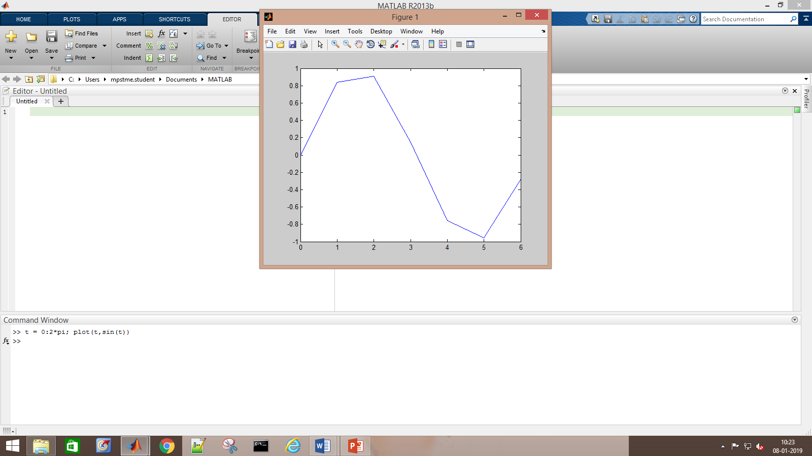

Comment:

t = 0:0.2:2\*pi; plot(t,sin(t))

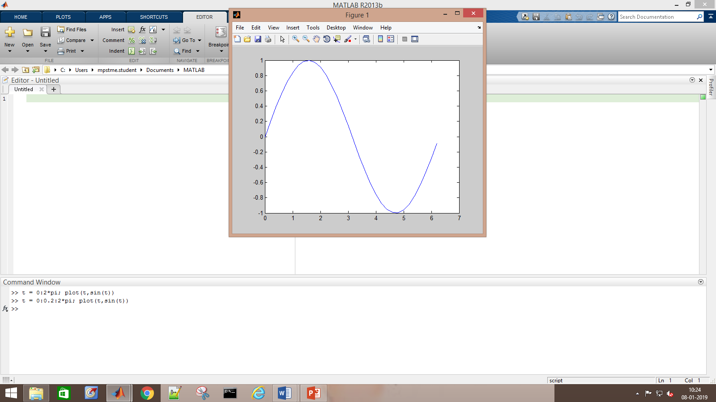

Comment:

t = 0:0.02:2\*pi; plot(t,sin(t))

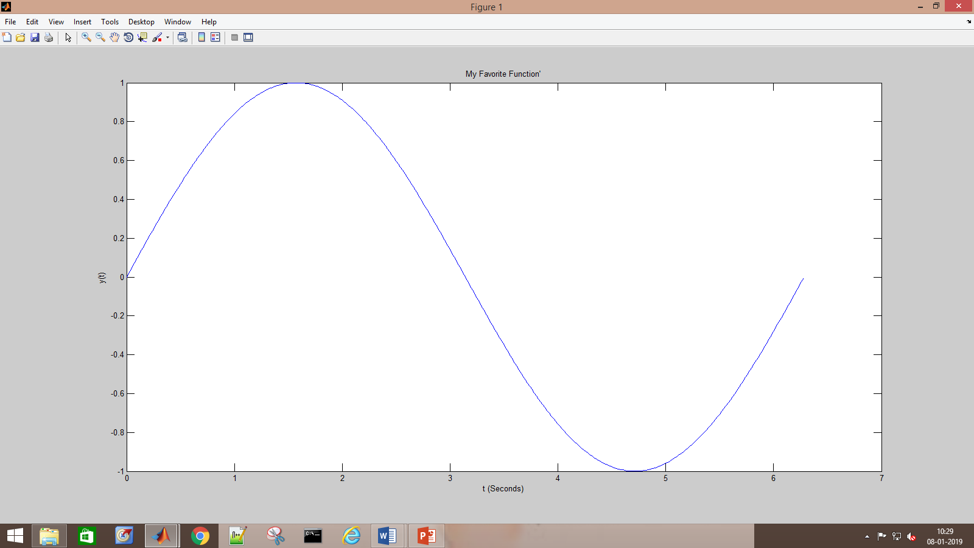

Comment:

axis([0 2\*pi -1.2 1.2])

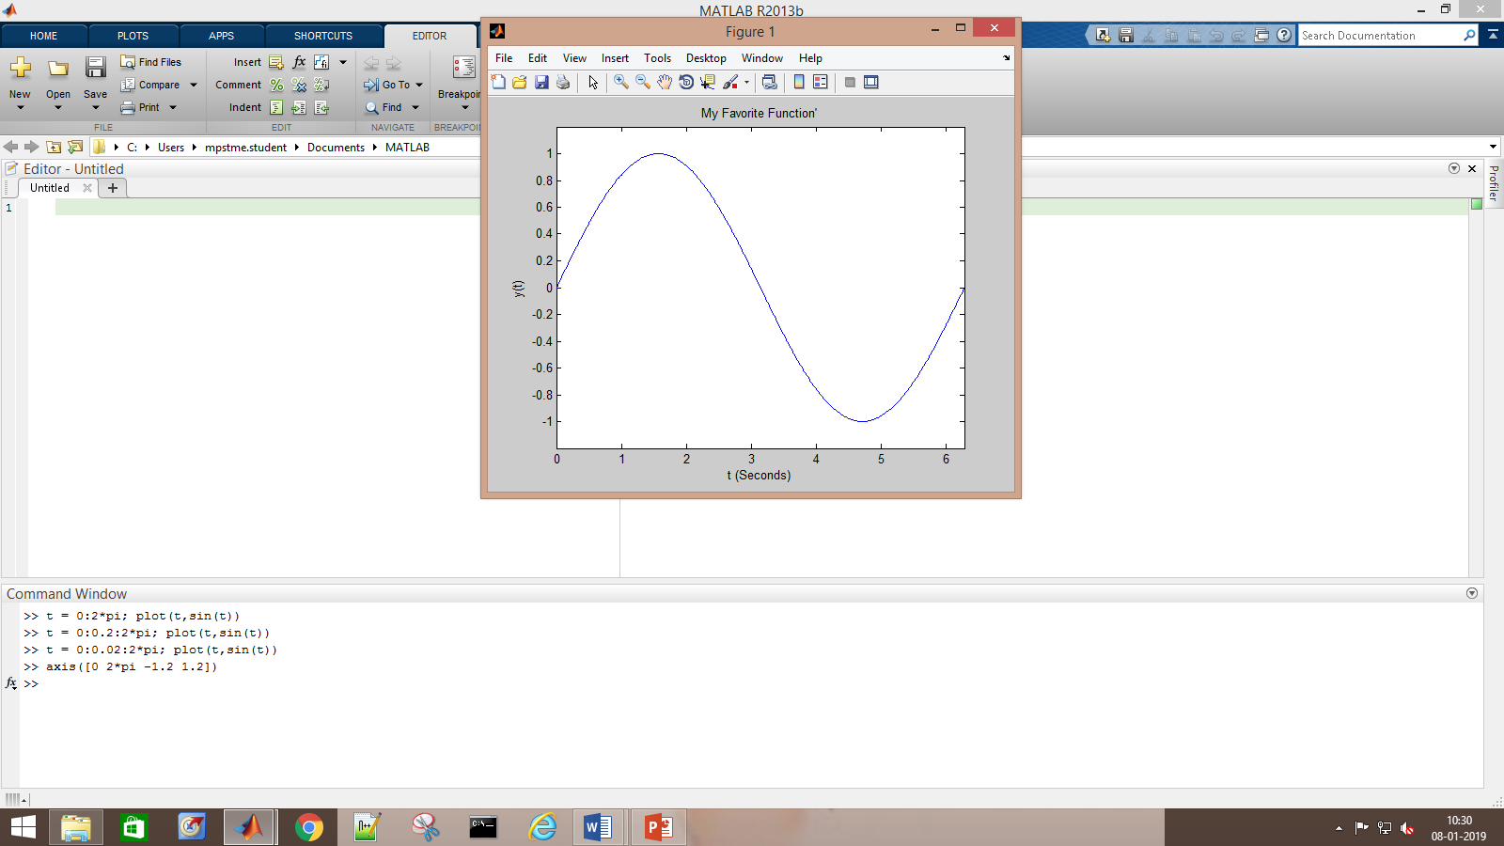

Comment:

t = 0:0.2:2\*pi; plot(t,sin(t),t,sin(2\*t))

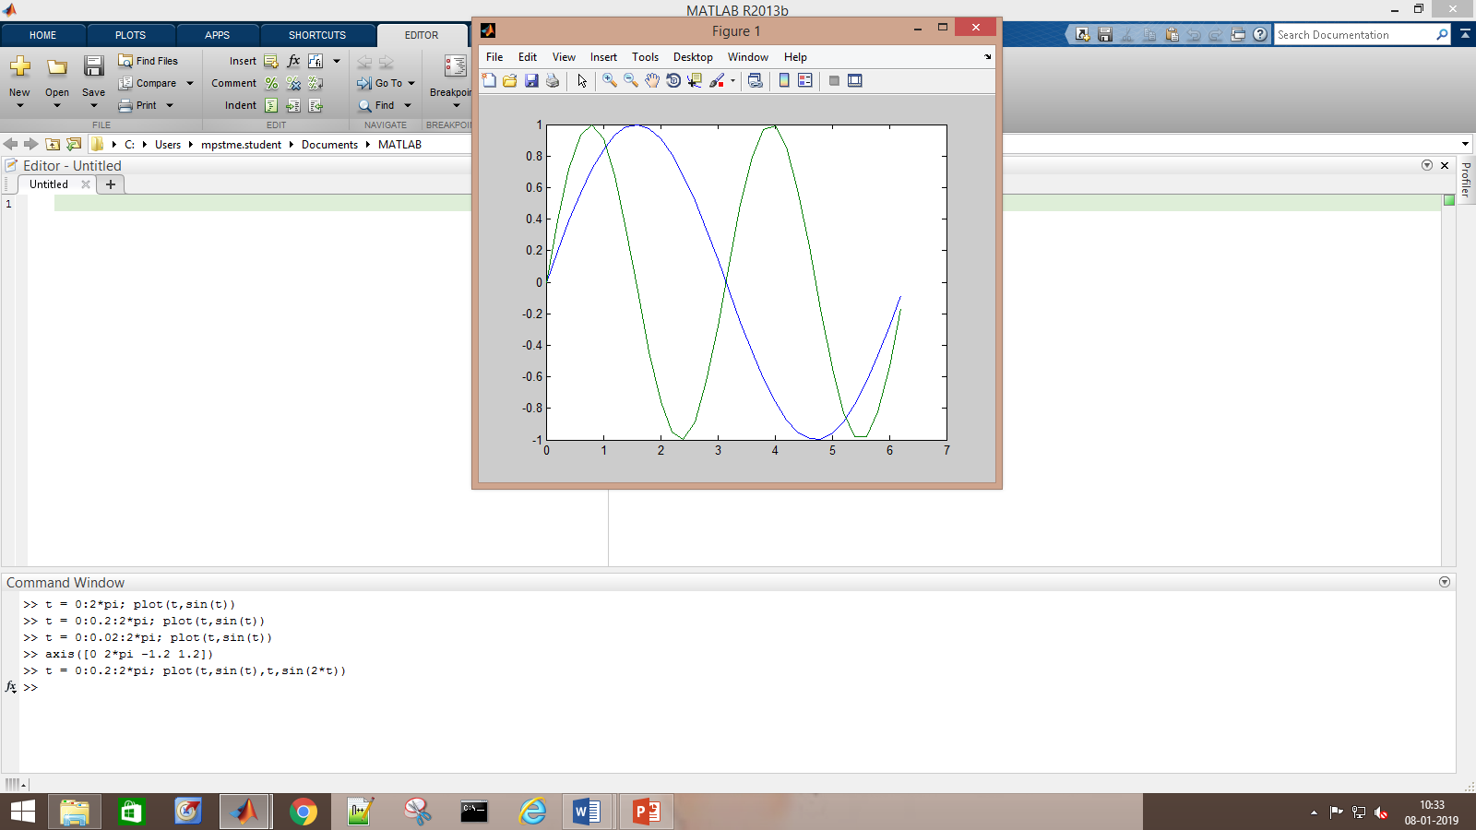

Comment:

Produce a plot without connecting the points:

t = 0:0.2:2\*pi; plot(t,sin(t),'.')

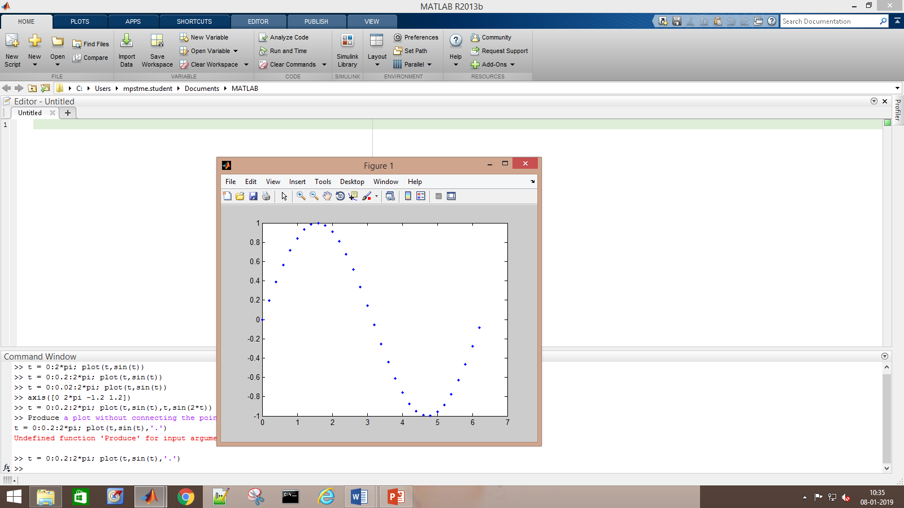

Comment:

Try the following command:

t = 0:0.2:2\*pi; plot(t,sin(t),t,sin(t),'r.')

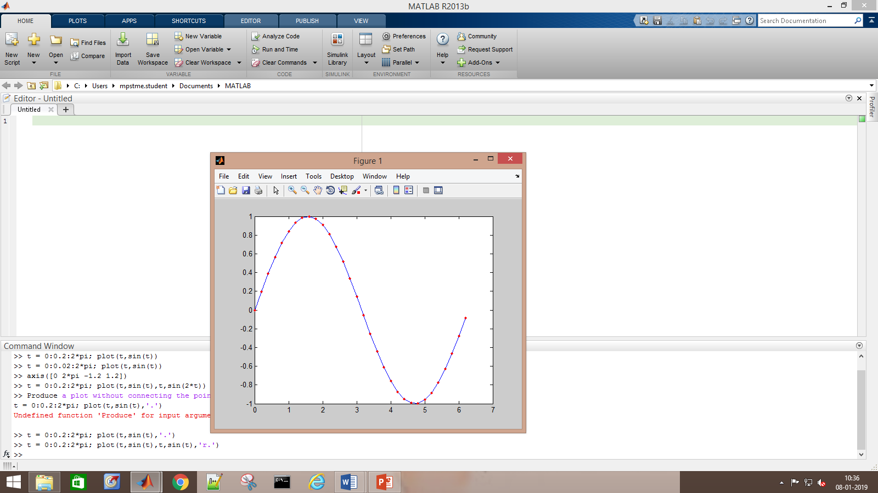

Comment:

Q2

1.

t = 0:2\*pi; plot(t,cos(t))

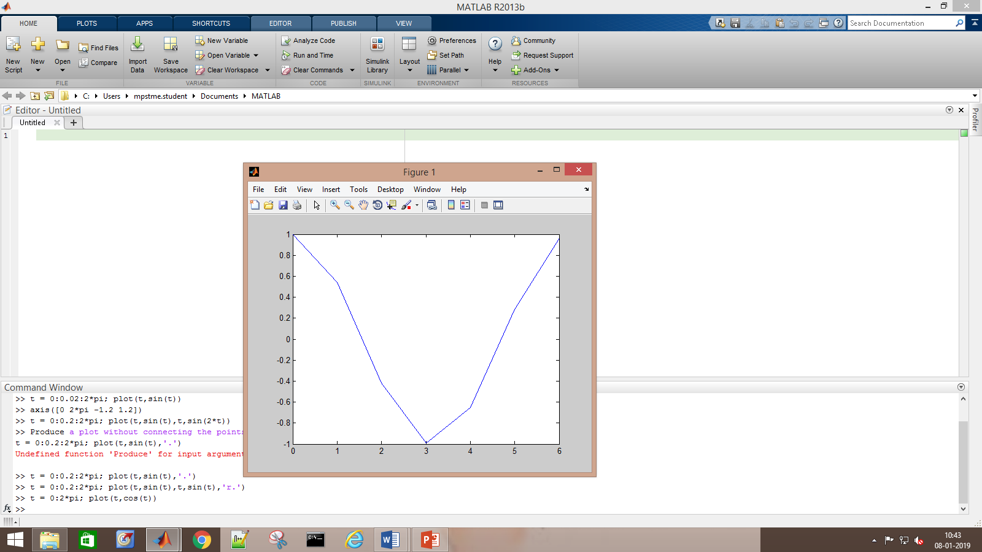

2.

t=(-5:0.2:10); unitstep=t>=0; plot(t,[unitstep])

>> axis([-5 10 0 4])

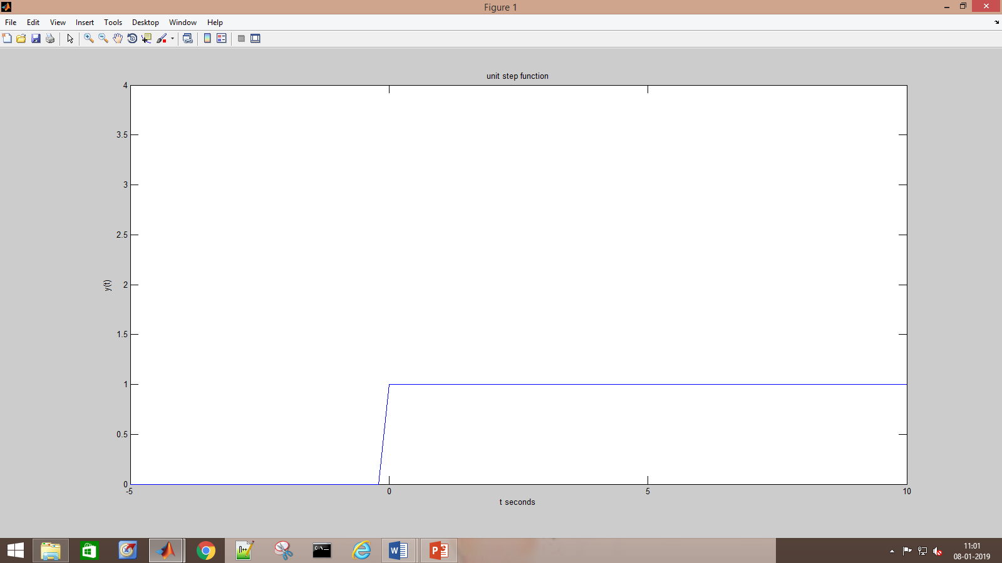

3.

ramp=t.\*unitstep; plot(t,[ramp])

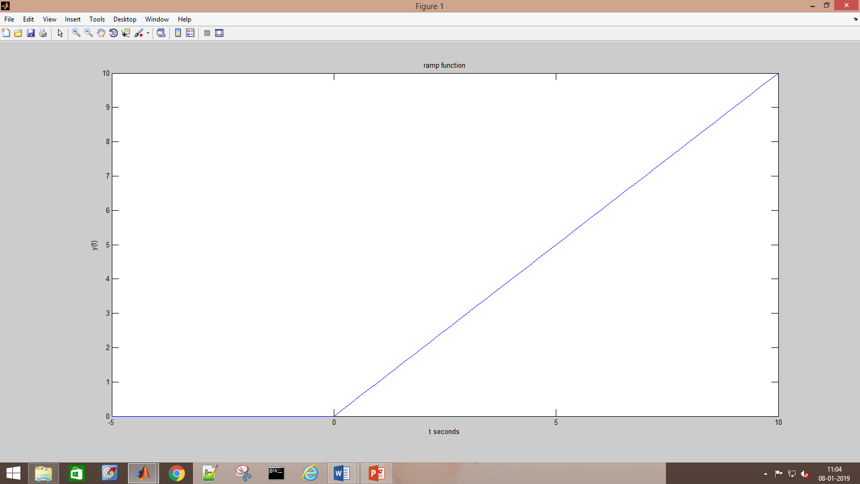

4.

Q3

1

t = 0:0.2:2\*pi; stem(t,cos(t))

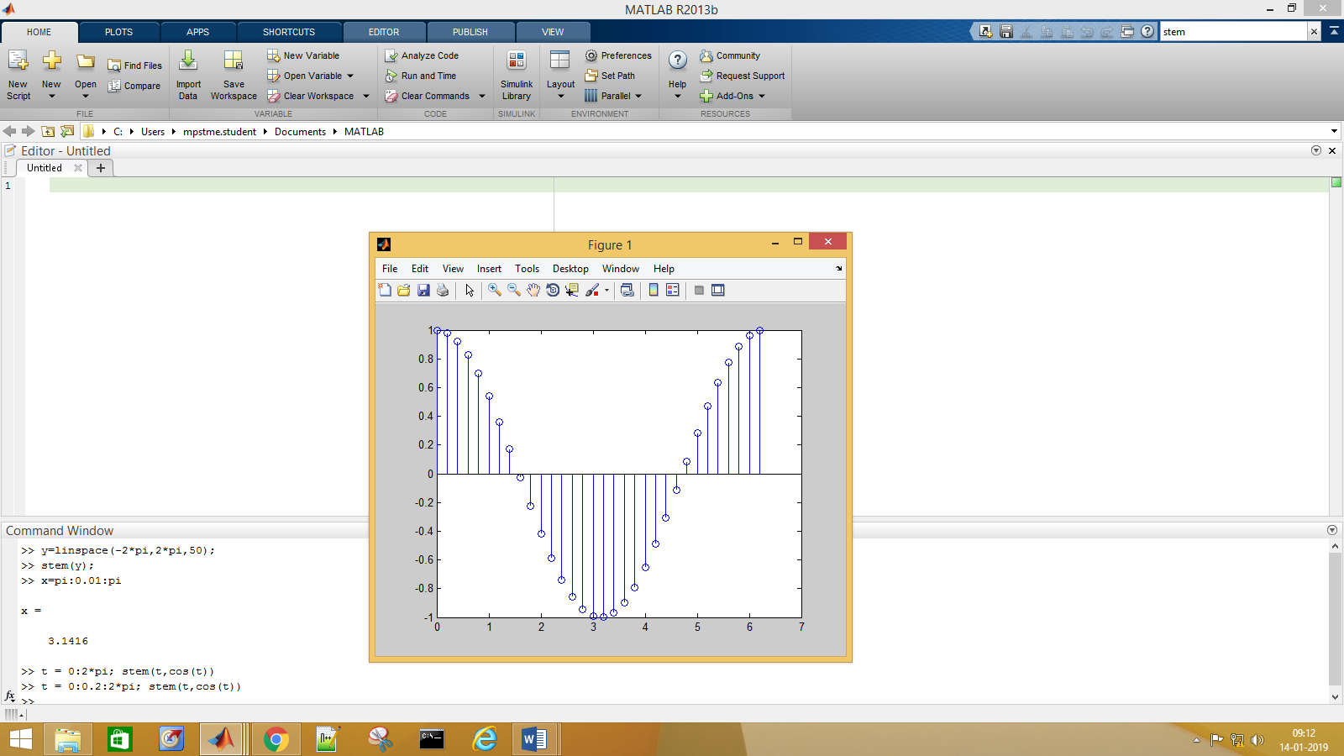

2.

>> t=(-5:0.2:10); unitstep=t>=0; stem(t,[unitstep])

>> axis([-5 10 0 4])

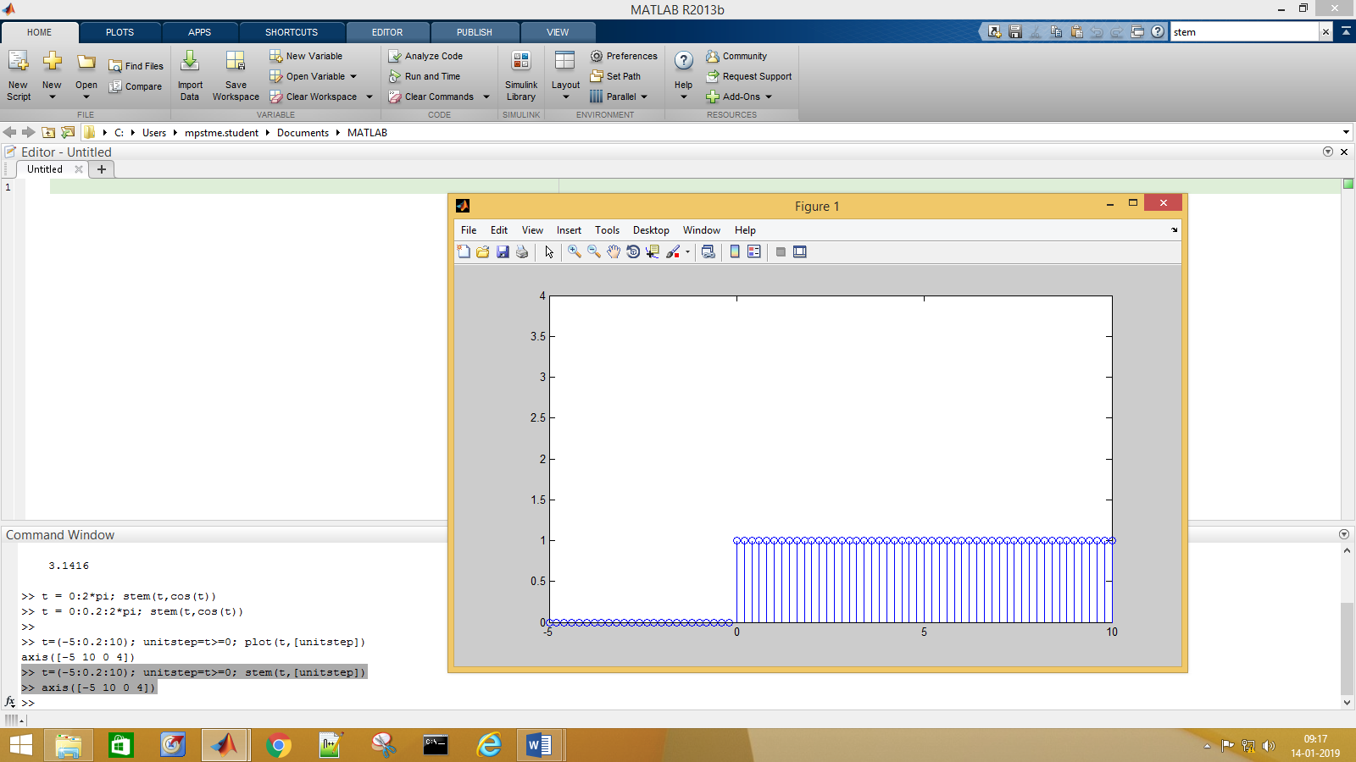

3.

ramp=t.\*unitstep; stem(t,[ramp])

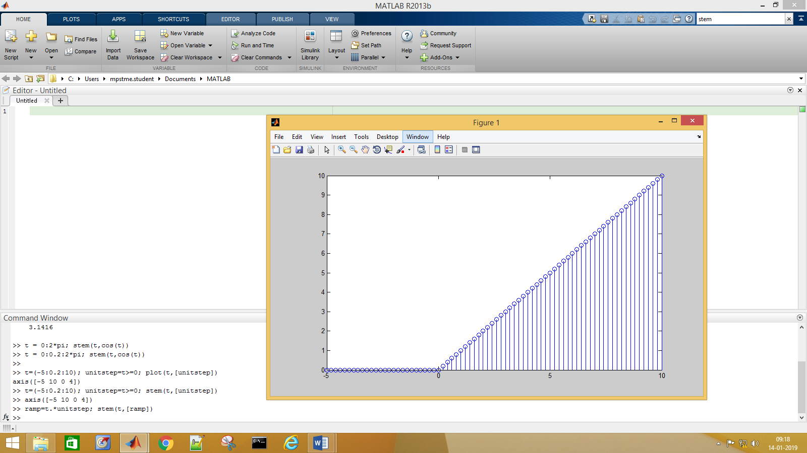

4.

t = -2\*pi:0.2:2\*pi; stem(t,sin(t))

